PROJECT TITLE: - SMART HOME ASSISTANT

VAMSI KRISHNA MEKALA 19R11A04C5

NEELA MEGHANA 19R11A04C9

NISHANTH POLKAMPALLY 19R11A04D0

P SAI GANESH 19R11A04D3

S DEERAJ YADAV 19R11A04D6

INTRODUCTION: -

Can your house be interactive? Well, that’s a crazy question isn’t it. Can you control all your household appliances with your phone? Much crazier right! This is possible with the help of SMART HOME ASSISTANT.

A SMART Home Assistant is a free and open-source software for home automation that is designed to be the central control system for smart home devices with focus on local control and privacy.

OVERVIEW: -

Smart Assistants enable advanced query building and machine learning outcomes for users with little to no Search Processing Language (SPL) knowledge. Built on the backbone of the Experiment Management Framework (EMF), Smart Assistants offer a segmented, guided workflow with an updated user interface. Smart Assistants let you quickly move from fitting a model on historic data to applying a model on real-time data and taking action.

PURPOSE: -

For most of us, the ultimate luxury would be an assistant who always listens for your call, anticipates every need of yours, and takes action when necessary. That luxury is now available thanks to artificial intelligence assistant’s aka voice assistants.

Voice assistants come in somewhat small packages and can perform a variety of actions after hearing a wake word or command. They can turn on lights, answer questions, play music, place online orders, etc.

Voice assistants are not to be confused with virtual assistants, which are people who work remotely and can therefore handle all kinds of tasks. Rather, voice assistants are technology based. As voice assistants become more robust, their utility in both the personal and business realms will grow as well.

EXISTING PROBLEM: -

Its always dreadful to see our power bills go up and also to switch on lights and off them every single time. Worry every time we go out as to whether you’ve locked the doors properly and everything is safe inside the house.

These problems need a one stop solution to have a better and happy life. These problems were the seeds for us to build a smart home assistant which will help us to control daily aspects of our life.

PROPOSED SOLUTION: -

So, we came up with a solution to control the above aspects with the help of integration of hardware and software.

A smart home assistant will help us control the temperature of our house, check on our appliances, security and many other aspects.

The Smart home assistant is your personal assistant which makes the tasks of the person.

It acts according to the person's commands. A home assistant helps the user in controlling appliances in the home easily by giving voice commands. This gives the temperature and humidity of the home and also, we can set reminders. Users can also send the messages to the desired person just by giving the voice inputs.

THEORETICAL ANALYSIS: -

BLOCK DIAGRAM: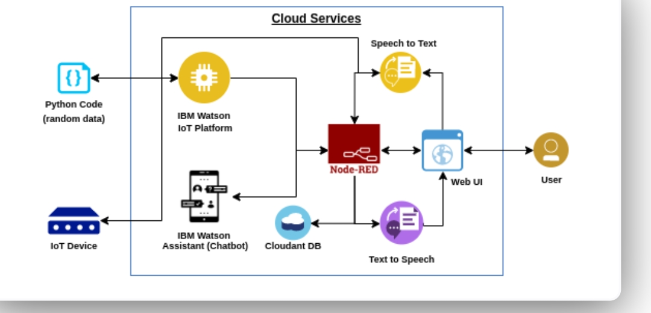

HARDWARE AND SOFTWARE DESIGN: -

SOFTWARE: -

~INSTALLING ARDUINO IDE

~DOWNLOADING DHT SENSOR LIBRARY

~UPLOADING THE CODE

~LOGIN IN TO IBM CLOUD

~CREATING IOT PLATFORM

~GENERATING API KEYS AND TOKENS

~SENDING THE DATA TO THE CLOUD

~RECEIVING THE DATA FROM THE CLOUD ( JSON )

~CREATING NODE RED SERVICES

~CREATING THE NODES IN ORDER TO READ TEMPERATURE AND HUMIDITY VALUES

~SHOWING THE OUTPUT IN THE DEBUG NODE

~CONVERTING THE DATA INTO PICTORIAL REPRESENTATION

~WITH THE HELP OF HTTP REQUEST AND RESPONSE NODES SENDING THE DATA TO WEBPAGE

~INSTALLATION OF UI NODES

~CREATING AN ASSISTANT IN IBM CLOUD

~INTEGRATING ASSISTANT WITH NODE RED WITH THE HELP OF UI NODES

~WITH THE HELP OF TEXT TO SPEECH AND SPEECH TO TEXT COVERTING THE OUTPUT INTO VOICE

HARDWARE: -

~DHT 11 SENSOR

~ESP 32

EXPERIMENTAL INVESTIGATION: -

1. After we embedded the code into the Arduino IDE, we connected the ESP 32 and DHT 11 sensor we were able to see the output accurately.
2. We created an IBM CLOUD account and then we generated API keys for us to create a node red service
3. We also tried to send the data to cloud and tried to receive it back.

The attempt was a SUCCESS.

1. The nodes we created for reading temperature and humidity displayed appropriate values and was displayed on web UI page.
2. Whatever output we got from the assistant will be converted into voice output form with the help of text to speech and speech to text nodes.

RESULT : -

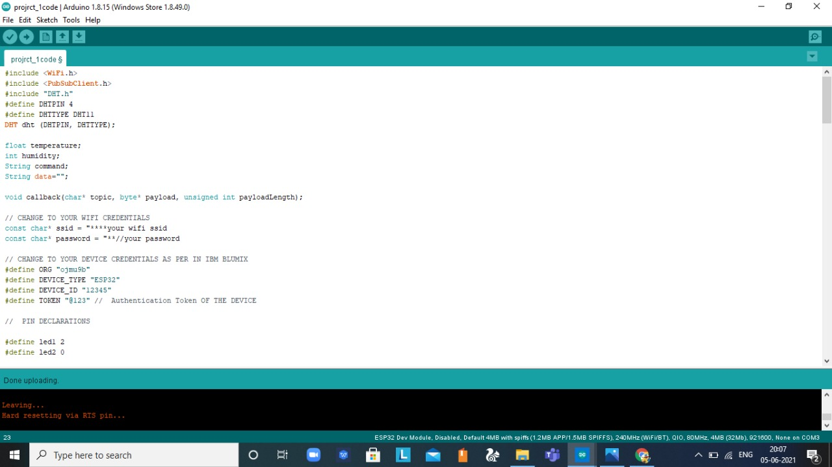



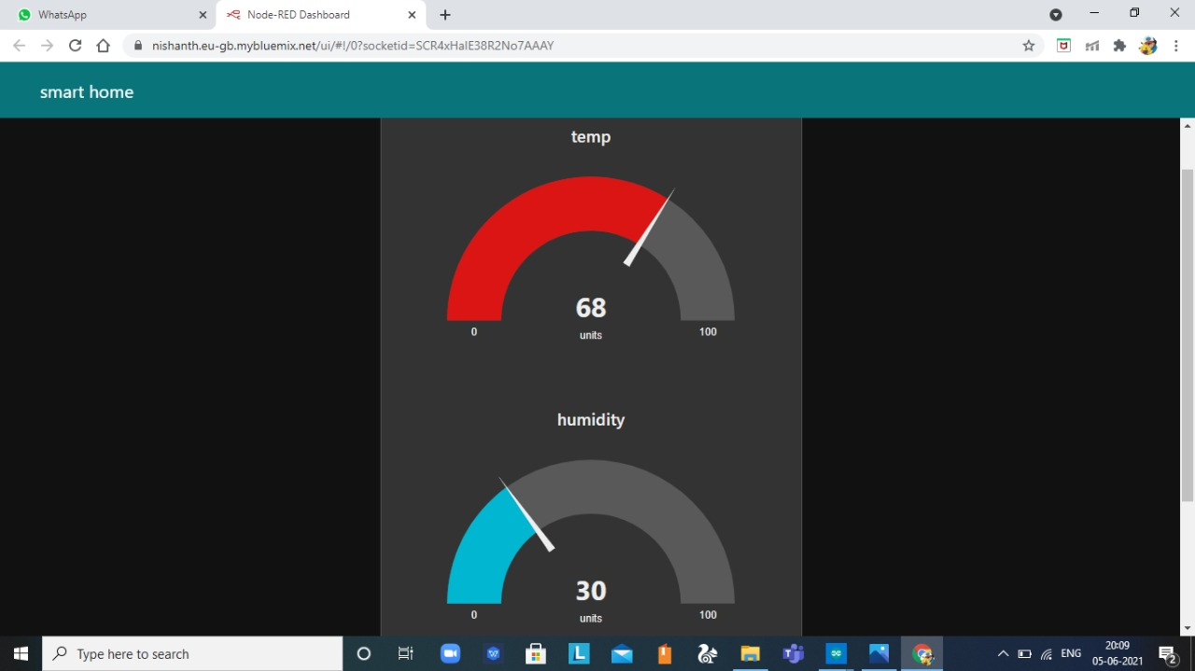

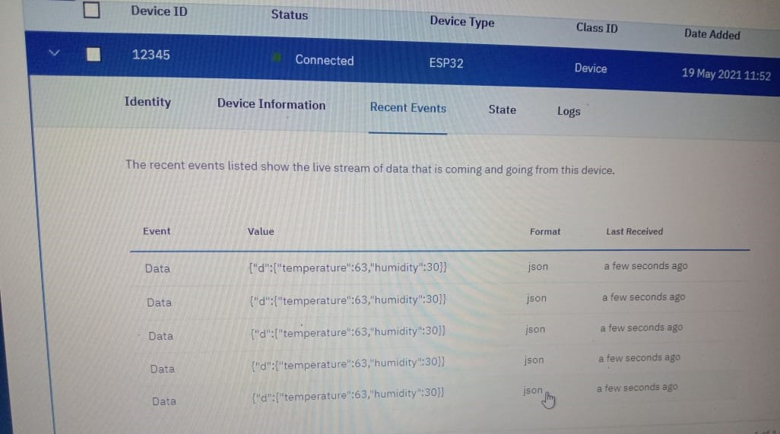

ADVANTAGES AND DISADVANTAGES: -

PROS:

1. Energy Savings

Home automation systems have definitely proven themselves in the arena of energy efficiency. Automated thermostats allow you to pre-program temperatures based on the time of day and the day of the week. And some even adjust to your behaviours, learning and adapting to your temperature preferences without your ever inputting a pre-selected schedule. Traditional or behaviour-based automation can also be applied to virtually every gadget that can be remotely controlled – from sprinkler systems to coffee makers.

Actual energy savings ultimately depend on the type of device you select and its automation capabilities. But on average, product manufacturers estimate the systems can help consumers save anywhere from 10 to 15 percent off of heating and cooling bills.

2. Convenience

In today’s fast-paced society, the less you have to worry about, the better. Right? Convenience is another primary selling point of home automation devices, which virtually eliminate small hassles such as turning the lights off before you go to bed or adjusting the thermostat when you wake up in the morning.

Many systems come with remote dashboard capabilities, so forgetting to turn off that coffee pot before you leave no longer requires a trip back to the house. Simply pull up the dashboard on a smart device or computer, and turn the coffee pot off in a matter of seconds.

3. Security

Remote monitoring can put your mind at ease while you’re away from the house. With remote dashboards, lights and lamps can be turned on and off, and automated blinds can be raised and lowered. These capabilities – combined with automated security systems – can help you mitigate the risks of intrusions: you will be alerted immediately if something uncharacteristic happens.

CONS

1. Installation

Depending on the complexity of the system, installing a home automation device can be a significant burden on the homeowner. It can either cost you money if you hire an outside contractor or cost you time if you venture to do it yourself.

2. Complex Technology

Automating everything in life may sound extremely appealing, but sometimes a good old-fashioned flip of the switch is a lot easier than reaching for your smart phone to turn lights on and off. Before you decide which system is right for you, think about how far you really want to take home automation in your household.

3. System Compatibility

Controlling all aspects of home automation from one centralized platform is important, but not all systems are compatible with one another. Your security system, for example, may require you to log in to one location to manage settings, while your smart thermostat may require you to log in to another platform to turn the air conditioner on and off. To truly leverage the convenience of home automation, you may need to invest in centralized platform technology to control all systems and devices from one location.

4. Cost

Even though the price of home automation systems has become much more affordable in recent years, the cost to purchase and install a device can still add up. Consumer Reports offers a wide range of information and insights – including costs – on the best home automation systems on the market.

APPLICATION1. Energy Savings

Home automation systems have definitely proven themselves in the arena of energy efficiency. Automated thermostats allow you to pre-program temperatures based on the time of day and the day of the week. And some even adjust to your behaviors, learning and adapting to your temperature preferences without your ever inputting a pre-selected schedule. Traditional or behavior-based automation can also be applied to virtually every gadget that can be remotely controlled – from sprinkler systems to coffee makers.

Actual energy savings ultimately depend on the type of device you select and its automation capabilities. But on average, product manufacturers estimate the systems can help consumers save anywhere from 10 to 15 percent off of heating and cooling bills.

2. Convenience

In today’s fast-paced society, the less you have to worry about, the better. Right? Convenience is another primary selling point of home automation devices, which virtually eliminate small hassles such as turning the lights off before you go to bed or adjusting the thermostat when you wake up in the morning.

Many systems come with remote dashboard capabilities, so forgetting to turn off that coffee pot before you leave no longer requires a trip back to the house. Simply pull up the dashboard on a smart device or computer, and turn the coffee pot off in a matter of seconds.

3. Security

Remote monitoring can put your mind at ease while you’re away from the house. With remote dashboards, lights and lamps can be turned on and off, and automated blinds can be raised and lowered. These capabilities – combined with automated security systems – can help you mitigate the risks of intrusions: you will be alerted immediately if something uncharacteristic happens.

The Cons

1. Installation

Depending on the complexity of the system, installing a home automation device can be a significant burden on the homeowner. It can either cost you money if you hire an outside contractor or cost you time if you venture to do it yourself.

2. Complex Technology

Automating everything in life may sound extremely appealing, but sometimes a good old-fashioned flip of the switch is a lot easier than reaching for your smart phone to turn lights on and off. Before you decide which system is right for you, think about how far you really want to take home automation in your household.

3. System Compatibility

Controlling all aspects of home automation from one centralized platform is important, but not all systems are compatible with one another. Your security system, for example, may require you to log in to one location to manage settings, while your smart thermostat may require you to log in to another platform to turn the air conditioner on and off. To truly leverage the convenience of home automation, you may need to invest in centralized platform technology to control all systems and devices from one location.

4. Cost

Even though the price of home automation systems has become much more affordable in recent years, the cost to purchase and install a device can still add up. Consumer Reports offers a wide range of information and insights – including costs – on the best home automation systems on the market.

APPLICATIONS: -

~Lighting control

~HVAC

~Lawn/Gardening management

~Smart Home Appliances

~Improved Home safety and security

~Home air quality and water quality monitoring

~Natural Language-based voice assistants

~Better Infotainment delivery

~AI-driven digital experiences

~Smart Switches

~Smart Locks

~Smart Energy Meters

CONCLUSION: -

We finally came up with a sophisticated application of smart home assistant to control the daily aspects of our life.

BIBLIOGRAPHY: -

~ SMART INTERNZ MENTORS

~SMART INTERNZ VIDEOS

~SMART INTERNZ MATERIAL

APPENDIX: -







THANK YOU